Local footpaths and open spaces surrounding Dorchester

Public meeting: **Tuesday 10th January**

**Dorchester Village Hall, 7.30pm**

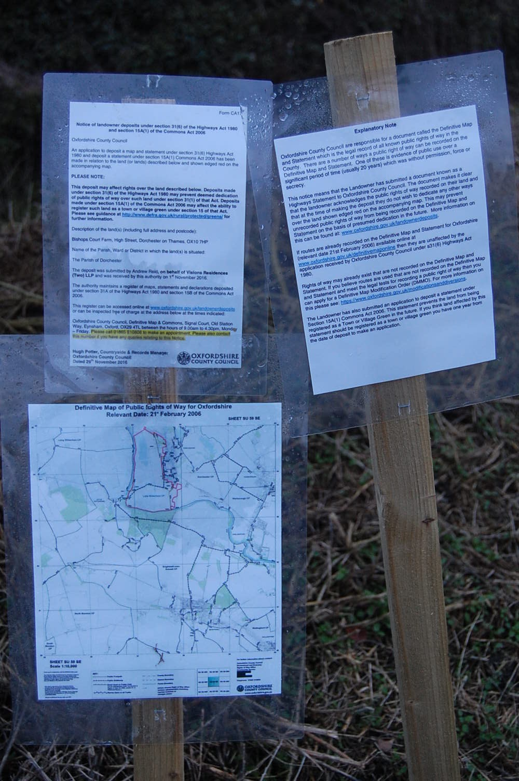

In response to the public notices placed at the end of Wittenham Lane by Oxfordshire County Council.

Are you interested in preserving footpaths and open access to the Dyke Hills and Days Lock area?

* Brief presentations by Becky Waller (Dorchester resident) and Kate Ashbrook and Chris Hall (Open Spaces Society).

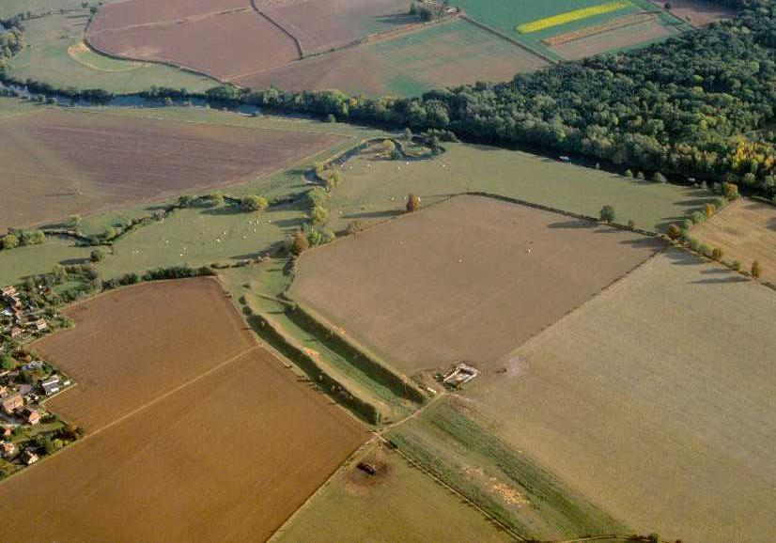

* An opportunity to share your own history and memories of the area (please bring photos of family, friends or events held in the past 20 years or more, particularly on the Dyke hills or the Days Lock meadow).
* Help to prepare a response to OCC.