25a Bell Street, Henley-on-Thames RG9 2BA
tel: 01491 573535 e-mail: hq@oss.org.uk website: www.oss.org.uk
(registered in England and Wales, limited company number 7846516,
registered charity number 1144840)

Taking action

Highways under threat

Challenging councils who have failed to make progress with definitive map change applications

August 2016

I would like to become a NEW member of the Open Spaces Society

□ Individual £33.00 pa
□ Joint individual £50.00 pa
□ Life membership £660
□ Local groups, parish councils, town councils £45.00 pa
□ National organisations, district & borough councils £165.00 pa
□ County Councils and Unitary Authorities £385.00 pa

Title: ………………… Forename/s: ……………………………………………………..

Surname: ………………………………………………………………………………………

Organisation/Council (if applicable): ………………………………………………………..

Address:........................................................................................................................

……..…………………………………………………………………………………………….

……………………………………………. Postcode ………………………………….

Tel: ……………………………………… Email:………………………………………………

I enclose a cheque for £ ……………… made payable to Open Spaces Society

□ I would like to pay future subscriptions by Direct Debit*. Please pay your first subscription by cheque

□ I would like the Open Spaces Society to be able to claim Gift Aid on my subscription and any donation I choose to make.

*Please download a direct debit form from our website or tick this box □ if you would like us to send you a direct debit form in the post.

Alternatively, you can join via our website at www.oss.org.uk/membership and pay by card or using the GoCardless direct debit option.
Our vice-chairman Phil Wadey explains why, in England, it is urgent for applicants for definitive-map changes to challenge councils which have failed to make progress with those applications.

In England the Deregulation Act 2015, which is shortly to come into effect, will trigger the closure of definitive maps to claims based purely on historical evidence, on 1 January 2026. It is therefore vital that we apply for additions where we have evidence.

Continuous review
Under the Wildlife and Countryside Act 1981, since 1983 the definitive maps of rights of way have been under ‘continuous review’. That is, the surveying authority (the county council or unitary authority) makes an order to modify the map one path at a time, instead of the previous system where changes were batched and the whole map was reviewed every so many years.

The council is required adequately to resource the duty to maintain its definitive map so that, for every application made by a member of the public to change the map, there should at least be a decision whether to make an order within 12 months of the applicant certifying that he has told the owners and occupiers of the application.

Very few councils have allocated enough staff to meet the 12-month requirement, although there are a few high achievers. Fortunately, the 1981 act made some provision for this. Under the current law (para 3(2) of schedule 14 to the 1981 act), 12 months after serving the certificate on the council confirming that the application process is complete, it is possible to make an application to the secretary of state (England) or Welsh ministers (Wales) that she or they direct the council to determine the application within a further set period of time.

The process for making a ‘direction application’ is straightforward, by email or letter, as there are no special forms (see the government guidance for England). We recommend that, before seeking a direction, you write to the council to ask why the application has not been determined.

Policy
The secretary of state and Welsh Ministers currently have the same policy for considering requests for directions. They look first at whether the council has a statement of priorities setting out its general way of deciding which applications to consider next, and then at whether that statement is reasonable. They check any actions the council has taken and its expressed intentions to act, including any estimate of when determination will take place. The general circumstances of the case and, importantly, the views of the applicant are also relevant.

Recent decisions can be found here for England and here for Wales although in mid-August there were no directions on the Welsh website.

Of particular interest are the comments made by inspectors on the reasonableness of council policies. For example, Bradford Metropolitan District Council was directed to determine a footpath application last year⁽¹⁾. The inspector found that the council’s general policy of prioritising was satisfactory, but went on to consider that a delay of nine years since the application had been made, with no prospect of the case starting to be examined for a further eight years, was unacceptable. The council was instructed within 12 months to make a decision whether to make an order.

In 2004 Cornwall Council received the certificate confirming notification of landowners and occupiers of land crossed by an alleged footpath⁽²⁾. The council did not expect to reach this case until 2024, some 20 years after the certificate was issued, meaning that some of the witness evidence would be over 40 years old. A direction was issued giving the council 18 months to reach a decision.

This last case raised two additional points. Firstly it was the second attempt to obtain a direction, the first having been unsuccessful in 2009. This shows that the secretary of state can change his or her mind about a direction when there is continued failure to make progress. Secondly, the applicant referred to earlier decisions of the secretary of state in which directions had been granted; the decision letter dismissed these arguments saying that each case is considered on its merits.

Before making an application, it is worth checking the council’s statement of priorities and asking when it thinks the application will be decided. If this is going to be a long time, an application for a direction would be worthwhile, even if there are no other features of the case that would raise its priority. Under the package of reforms in the Deregulation Act 2015 which will be introduced in England later this year, it will no longer be possible to request the secretary of state to give a direction. Instead, applicants must go to the magistrates’ court.

The major drawback of the new approach is the cost: current court fees are £205 to commence proceedings and £515 for a contested hearing; these will deter many. If you are conducting systematic research, we advise you to go to court with a number of applications simultaneously since one fee will cover them all. But for many, the ability to get councils to act more quickly will be lost.

So we urge anyone in England whose application has remained undetermined for more than 12 months to request a direction to determine, and thereby benefit from the pre-deregulation system. Applicants for Welsh paths need not worry for now, though it is probably worth getting on with it.

For an example of two representations on Hampshire applications see here. They may be more detailed than you need, but note the reference to the third reading of the Wildlife and Countryside Bill in the House of Lords on page 2, which sets out the government’s intentions for the provision.

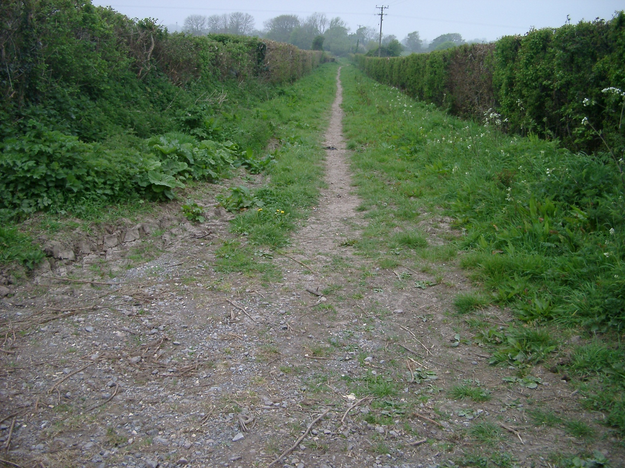

Green Lane, Ilminster, Somerset. The application was made in 2010. The secretary of state has directed that it be determined by 14 July 2017⁽³⁾. Photo: Sarah Bucks.

(1) FPS/W4705/14D/2 dated 8 June 15.
(2) FPS/D0840/14D/10 dated 8 June 16.
(3) FPS/G3300/14D/2 dated 14 July 16.

© Open Spaces Society, August 2016

